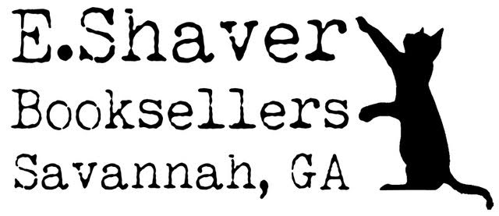

E. Shaver, Booksellers BOOK FAIR AGREEMENT

- E. Shaver will supply books and merchandise to {name of school} for a book fair taking place at the school {date}.

- E. Shaver will create a book list for the fair for the school to review. We will include additions from the school librarian. We aim to agree on a final list by {Date} After that time, further changes to the book list may not be possible.

- E. Shaver will deliver the books to the school prior to the fair, set up the fair, staff the book fair, and then remove any unsold items at the close of the book fair.

- Sales will be processed by the E. Shaver staff. Cash and credit cards will be accepted forms of payment.

- Any available restock of books during the fair will be brought to the school by E. Shaver staff. Backorders for sold-out books can be placed during the fair. E. Shaver will make every effort to get all the backordered titles. On rare occasions, a publisher may be out of stock of a title, and we won’t be able to fulfill a request.

- After the fair, the school will receive 25% of the pre-tax total book sales. The school may choose to set aside some or all of its share to buy books from E. Shaver for the school at a 20% discount.

For E. Shaver, Booksellers for the school

